**Origami Box Tutorial**

Materials needed

* A square of Stampin’ Up Designer Series paper your choice recommended size to start is 7’’x7’’ and up.
* Bone folder

Instructions

1. Start with your cut square at 7’’ x7’’ and up. You can make the box in smaller sizes but it is easier to do the folds on a larger size until you get the hang of the folds. Fold the square in half one way then open it and fold again in the other direction. Be sure to use your bone folder on all creases. Turn paper and fold at a diagonal.
2. Take the folded triangle shape and fold point A up and inside to point B. Fold along the folded lines you previously made. Your folded shape should look like the second picture.

**B**



1. Repeat the fold on the opposite corner your folded shape should be a diamond with open folds on the top and creases on the bottom. Turn the side of the diamond like a book and then using your bone folder make a sharp crease down the center vertical line on both sides. This will serve as a guildeline for future folds. Next using the center fold as a guide fold a triangle flap to the center, some of the diamond will show up behind.

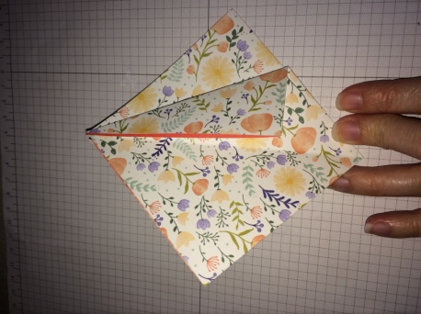

Repeat for the other side. New shape should look like picture below.

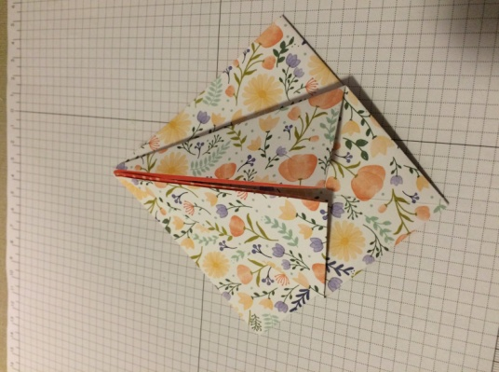

1. 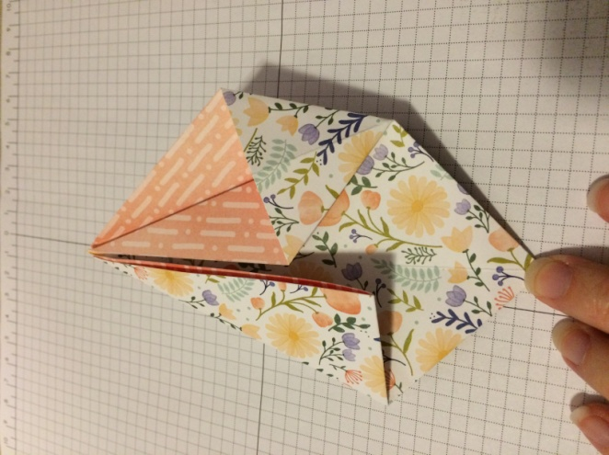Flip piece over to the backside and repeat the top side flap folds new shape should like below. Next open one of the side flaps by putting a finger or bone folder into the fold and fold the bottom of the flap into a small triangle.

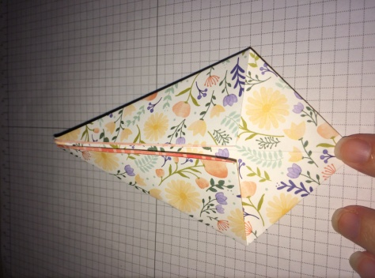

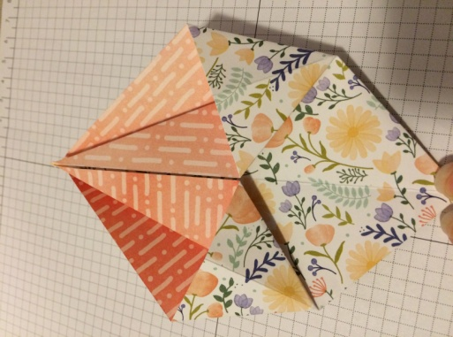Repeat the fold on the opposite flap, then flip the piece over and repeat on the opposite side.

1. Now you will fold the side over like you are turning the page in a book. If all your creases have been centered then this should be fairly simple to just fold it over. You will then fold back the top tall triangle. It was one of your outer sails on the sailboat from our previous shape. Dark black lines represent folded lines from previous folds as guides. Turn the shape over and repeat side folds on the opposite side.

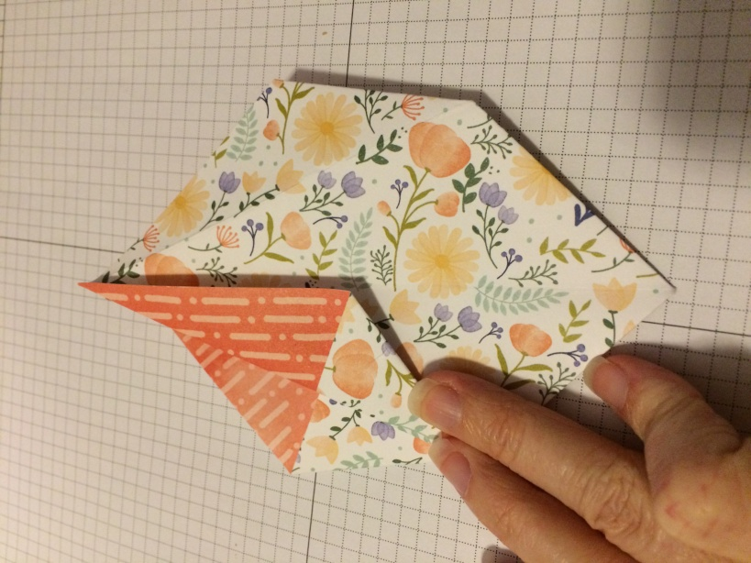

1. If folded correctly your shape should look like the picture below. The points at the top are sharp but open flaps and the bottom of the shape is a solid closed fold.

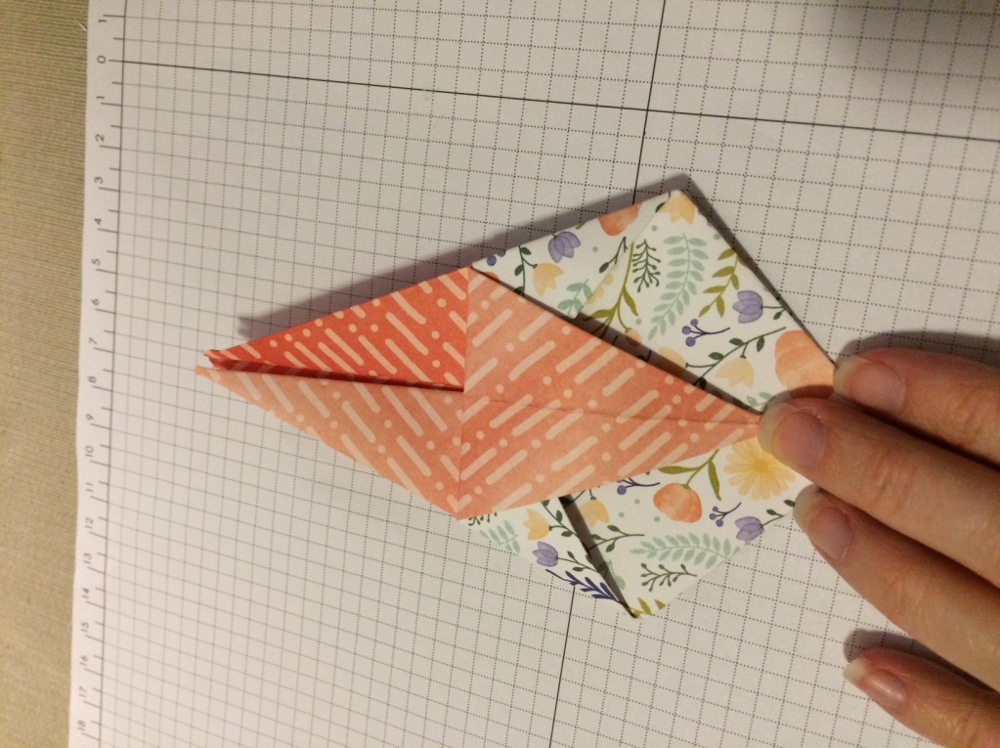

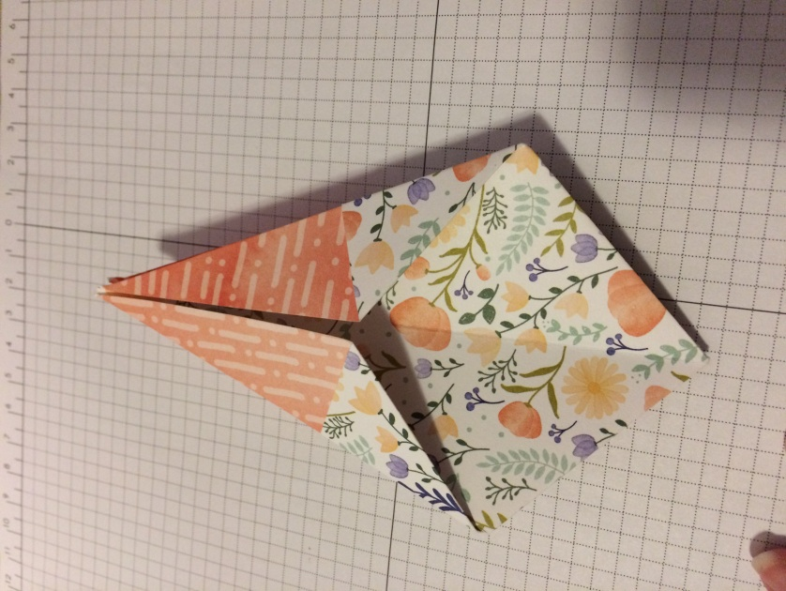

1. Now fold the top point down like an individual petal and crease the edge. Turn the side like a page in a book then fold down the next top petal. Continue turning and folding until you run out of petals. The shape should look like the pictures below with an opening at the top and four side triangles.

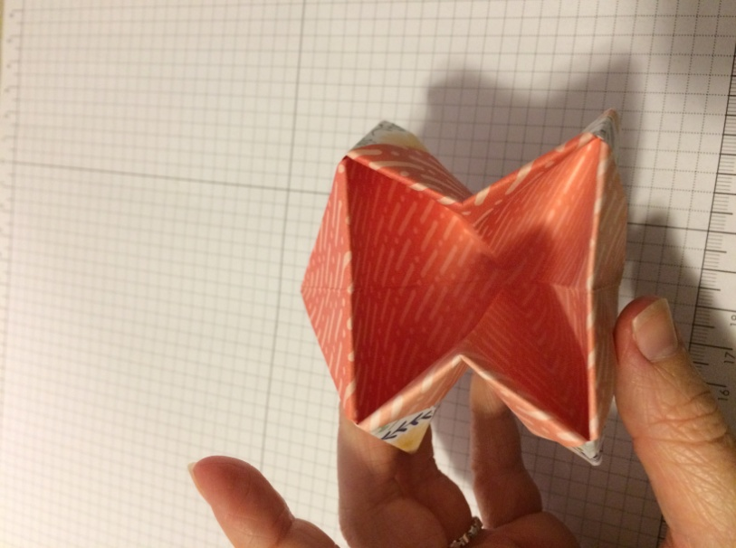

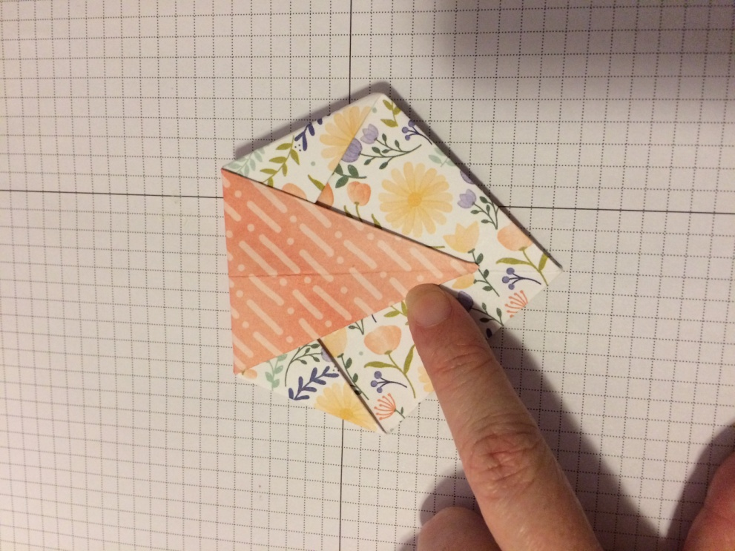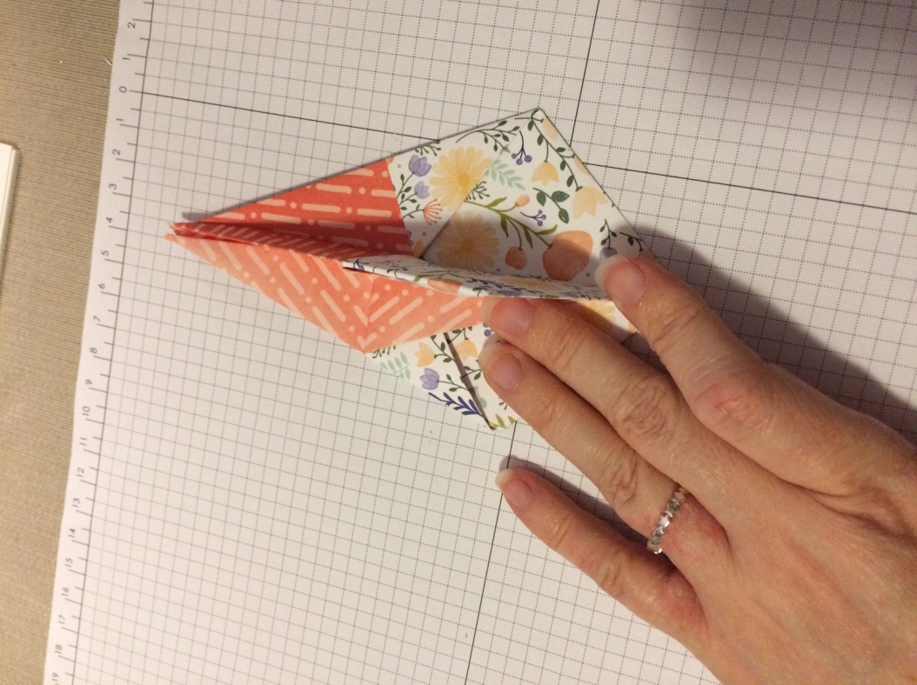

1. 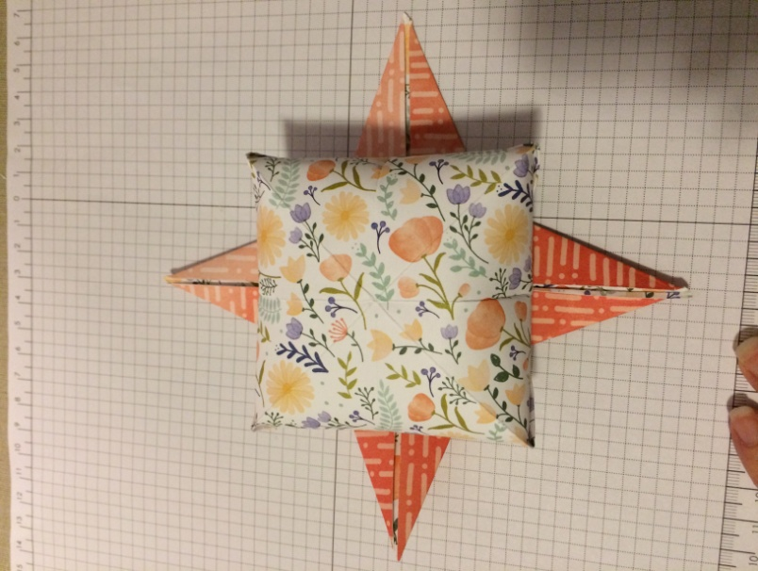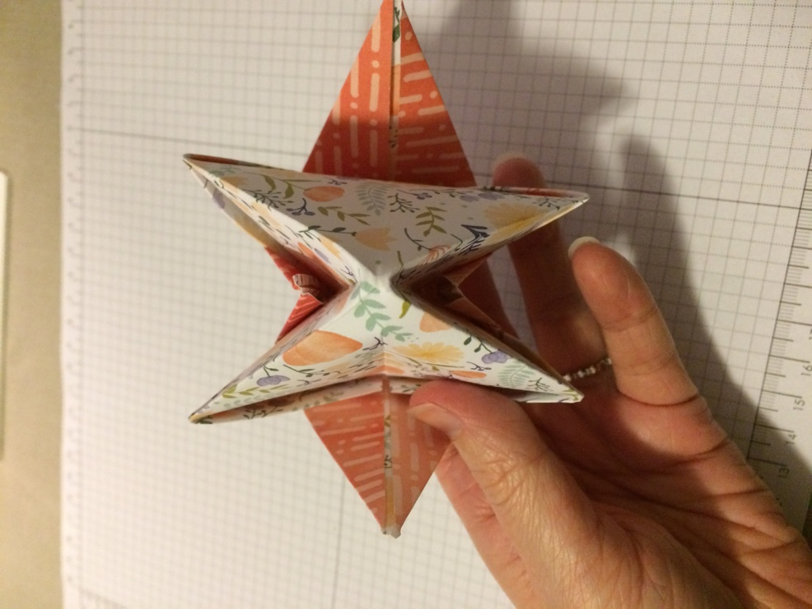Now is time for your box to finally take shape. Put your fingers in the top of the shape and gently smooth out the side creases. As you work the box should start to take shape. The bottom point of the triangle will become the center of the box base. When completed the box should look like the picture below. The four side flaps are loose but you can fold them over and glue them down if you prefer.

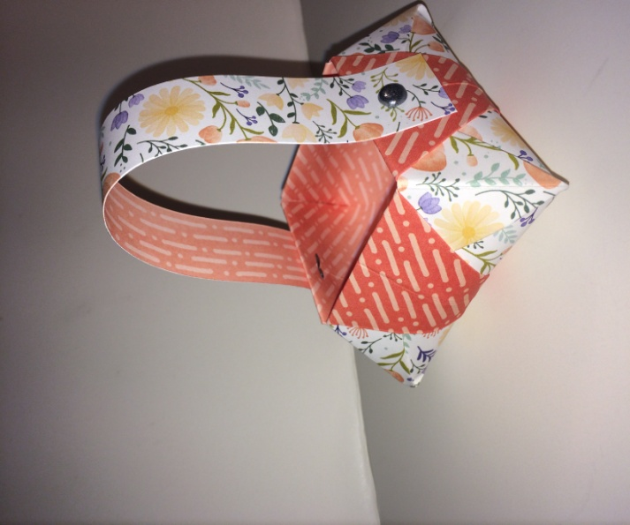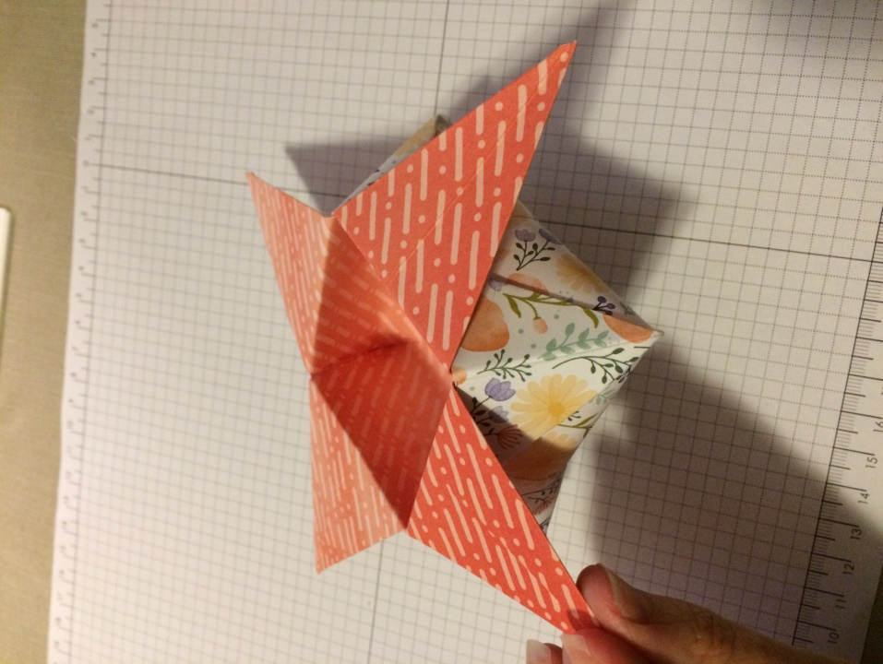]

To finish off your box you can add a strip of extra DSP to coordinate with your project the handle pictured is 1’’ x 8” and attached to the sides using brads.

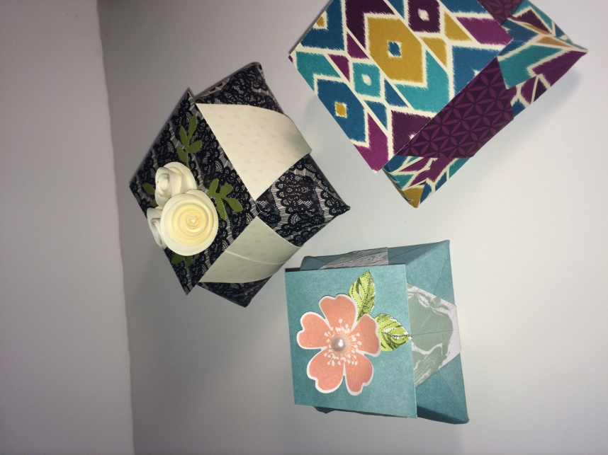A lid can also be added by measuring the opening of your box and cutting two pieces of paper one that is larger than the lid as the flat top and one that is smaller than the opening which is cut and scored like the picture. The smaller piece will make a small square that will attach to the underside of your flat lid piece and will keep the lid secure from sliding off.

This tutorial was created by: Stampin’ Up Demonstrator Michelle Carter

[www.michellescraftcorner.com](http://www.michellescraftcorner.com)

[www.facebook.com/michellescraftcorner](http://www.facebook.com/michellescraftcorner)

Score along the dotted line.

Cut solid line tabs on the four corners and fold along the scored lines.

Fold and glue the tabs in to create a simple box.